Chinese parliament re-elects Xi as president
Sat Mar 17, 2018 06:21AM
Asia-Pacific
China
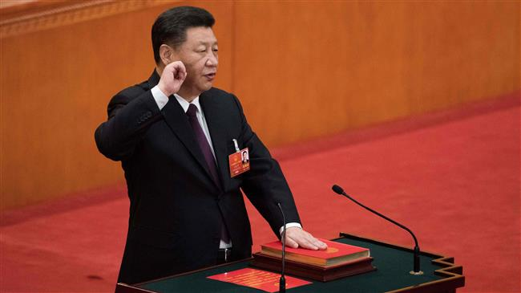 China’s President Xi Jinping swears under oath after being elected for a second term during the fifth plenary session of the first session of the 13th National People’s Congress (NPC) at the Great Hall of the People, in Beijing, on March 17, 2018. (Photo by AFP)
Xi received a standing ovation from the legislature after winning almost every one of the 2,970 votes. Only one delegate voted against Wang’s appointment.
The incumbent Chinese president reportedly aims to expand his years-long campaign against corruption within the ruling party through the creation of a new National Supervisory Commission.
At the frontline of Xi’s anti-corruption crusade, Wang headed the party’s Central Commission for Discipline Inspection, punishing 1.5 million officials in the past five years, from low-level cadres to local leaders and generals.
The 69-year-old stepped down from the Communist Party’s ruling council in October last year.

